Creating an NTFS Simple Volume to Store Windows Response Evidence

Step | Action
1 | Click the Start button.  Student Notes: Right-click Start to locate Computer Management.  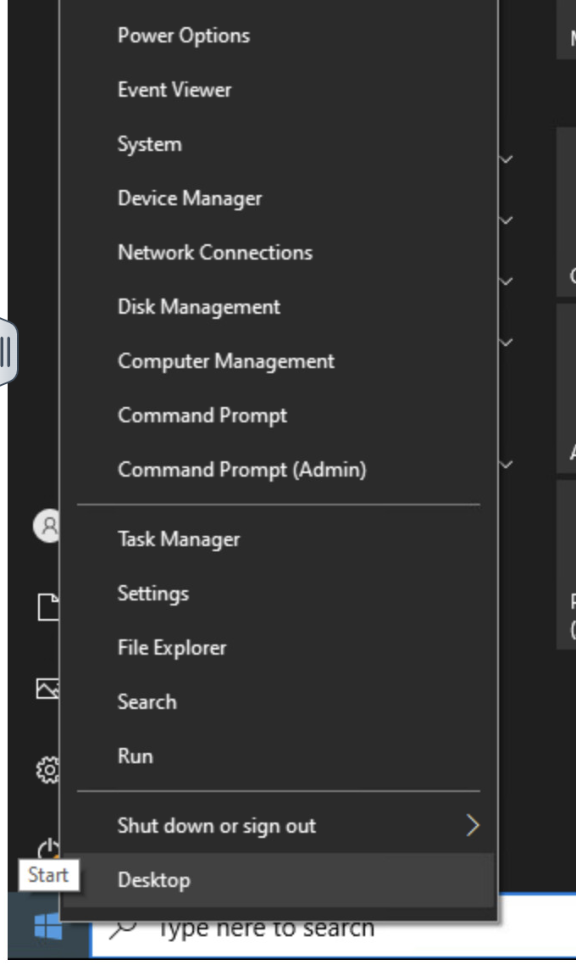
2 | Right-click Computer Management and select Device Manager.  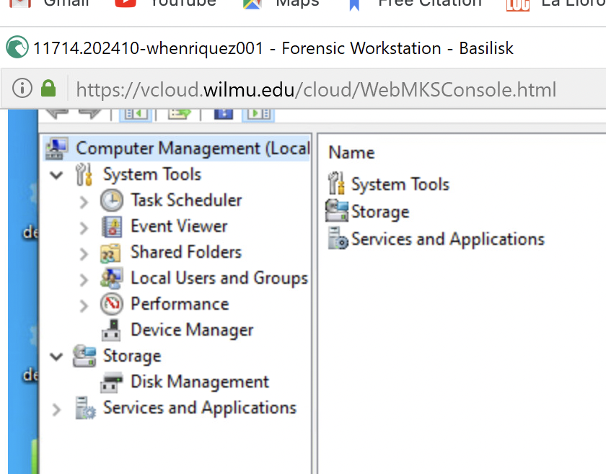
3 | Select Disk Management.  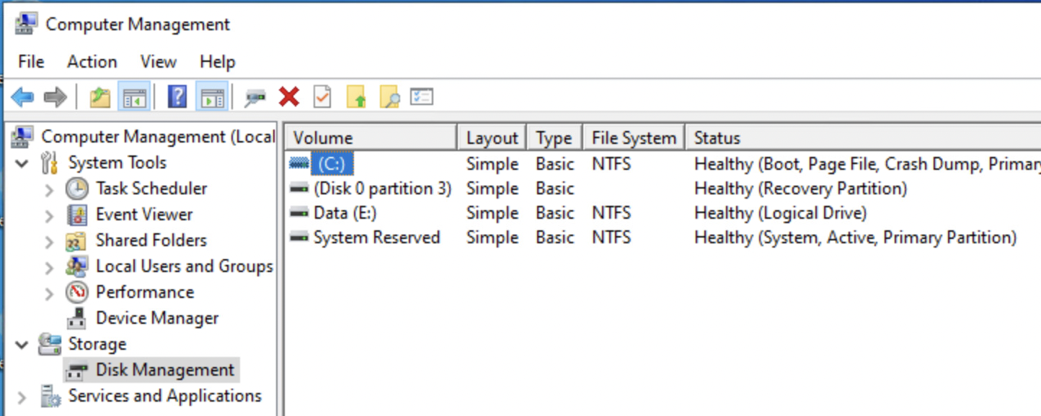
4 | Click in the Unallocated space area of the 1 GB drive to highlight it. Right-click and click New Simple Volume. This will bring up the New Simple Volume Wizard. Click Next. 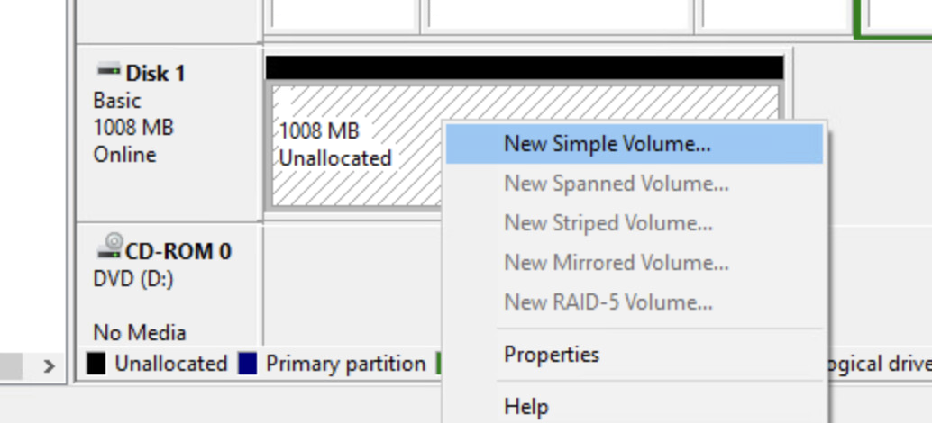 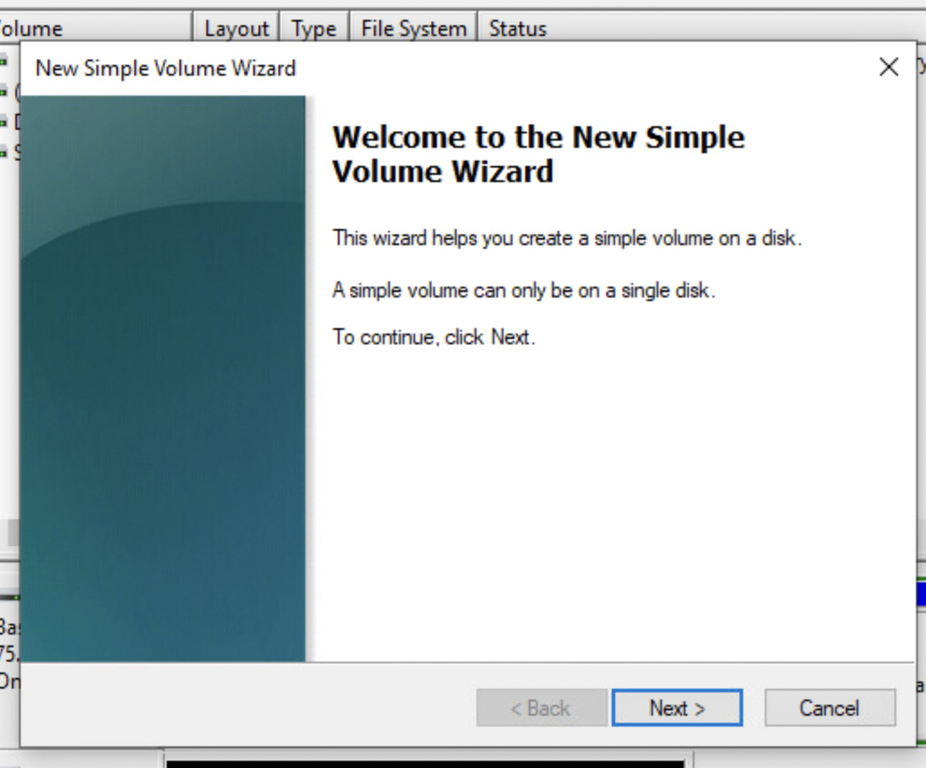
5 | 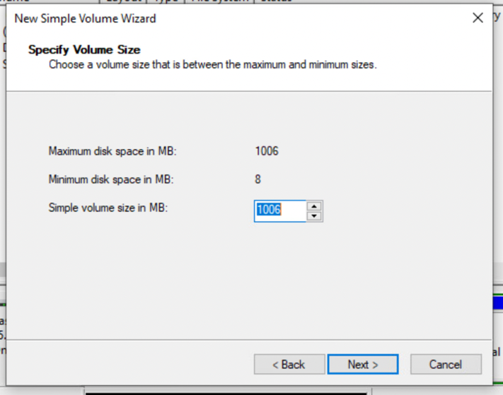  Under Specify Size, accept the default size. Click Next.
6 | Under Assign Drive Letter or Path window, use the drop-down menu to specify a drive letter (S), and click Next. ("S" to indicate a storage drive)  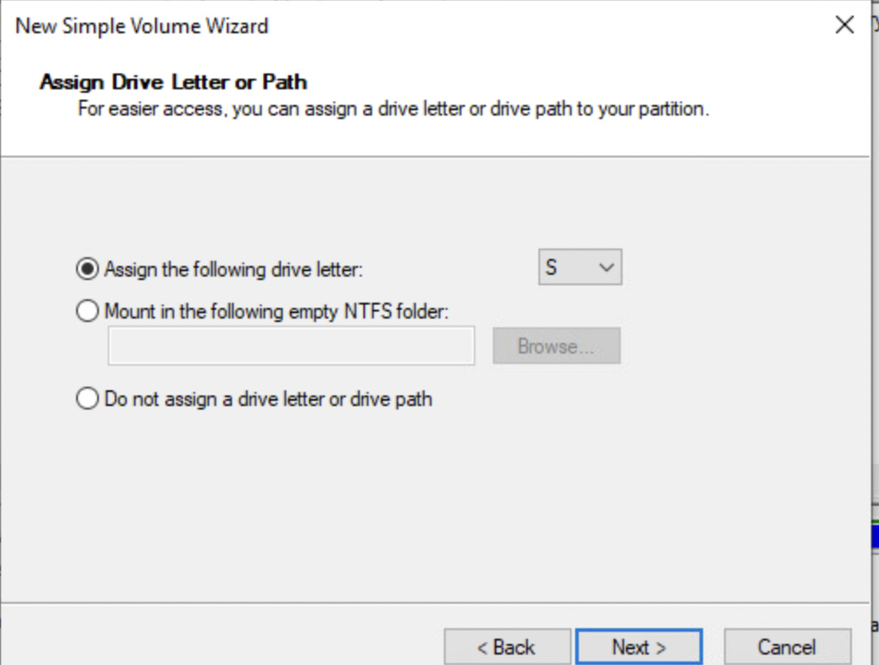
7 | Select the following configurations  - Select Format this partition with the following settings  - Under File system click on the drop down menu and select NTFS  - Undedr Allocation Unit Size select Default.  - Under Volume label select Evidence.  - Select Perform a quick format then Next.  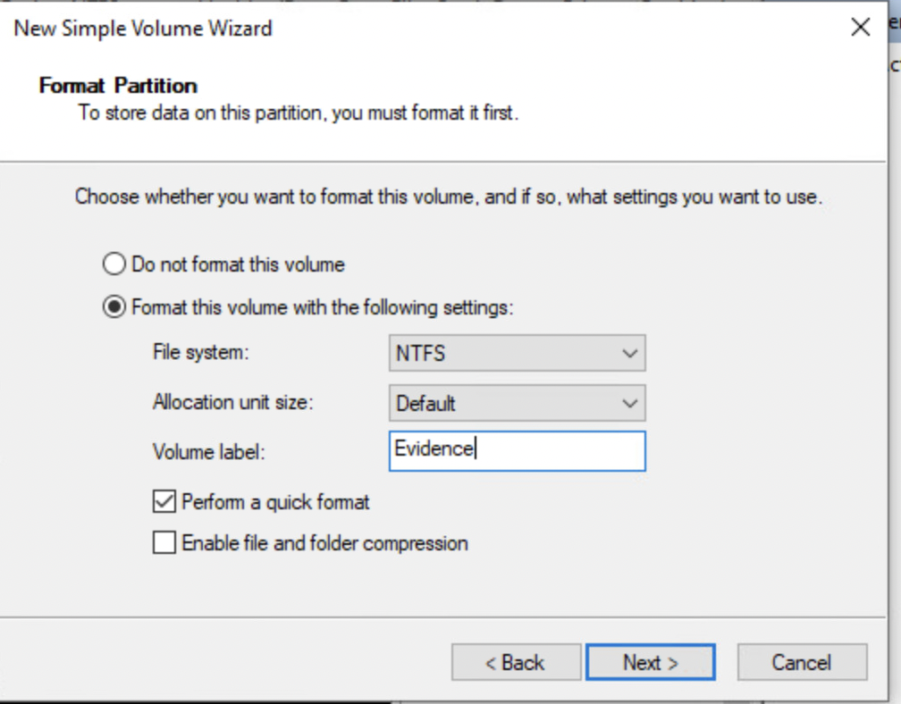  You will then the Partition was created.  